ASSIGNMENT 11

- WAP that reads a string and converts to uppercase
//WAP that reads a string and converts it to uppercase
#include<iostream.h>
#include<conio.h>
#include<stdio.h>
main()
{
char str[50];
cout<<"\n\nEnter a string ";
gets(str);
for(int i=0;str[i]!='\0';i++)
{
if (str[i]>=97 && str[i]<=122)
str[i]-=32;
}
cout<<str;

getch();
}
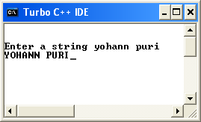

- WAP that checks whether a character is uppercase or lowercase

// WAP that checks whether a character is uppercase or lowercase
#include<iostream.h>
#include<conio.h>
#include<stdio.h>
main()
{
clrscr();
char ch;
cout<<"\n\nEnter a character ";
cin>>ch;
if (ch>=97 && ch<=122 || ch>65 && ch<90)
{
cout<<"It is an alphabet";
if(ch<97)
cout<<endl<<"It is an uppercase character ";
else
cout<<endl<<"It is a lowercase character ";
}
else
cout<<"It is not an alphabet";
getch();
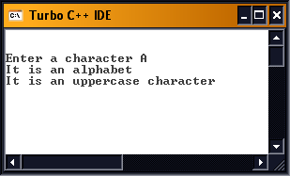
}

- WAP to concatenate 3 strings of a name

//WAP to concatenate three strings of a name
#include<iostream.h>
#include<conio.h>
#include<stdio.h>
main()
{
clrscr();
int i=0,j=0;
char fn[15],mn[15],ln[15],jn[45];
cout<<"\nEnter first name ";
cin>>fn;
cout<<"Enter middle name ";
cin>>mn;
cout<<"Enter last name ";
cin>>ln;
for(j=0;fn[j]!='\0';i++,j++)
jn[i]=fn[j];
jn[i++]=' ';
for(j=0;mn[j]!='\0';i++,j++)
jn[i]=mn[j];
jn[i++]=' ';
for(j=0;ln[j]!='\0';i++,j++)
jn[i]=ln[j];
jn[i++]='\0';
cout<<jn;
getch();
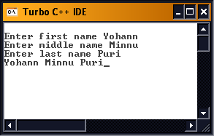
}

- WAP that reads password and checks if it is correct

// WAP that reads password and checks if it is correct
#include<stdio.h>
#include<iostream.h>
#include<conio.h>
main()
{
clrscr();
char pass[20],actual[20]="yohannpuri";
int i=0,flag=0;
start:
cout<<endl<<"Enter a Password ";
for(i=0;i<20;i++)
{
pass[i]=getch();
if(pass[i]=='\r')
break;
cout<<'*';
}
for(i=0;actual[i]!='\0';i++)
{
if(pass[i]!=actual[i])
{
cout<<endl<<"SORRY";
flag++;
cout<<endl<<"You have "<<3-flag<<" tries remaining";
if(flag==3)
goto end;
else
goto start;
}
}
cout<<endl<<endl<<"OK!!";
end:
getch();
}

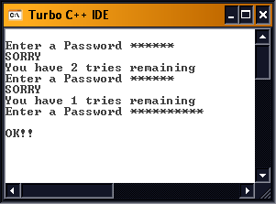

5) WAP that reads two strings and copies the smaller one into the bigger one

// WAP that reads two strings and copies the smaller one into the bigger one
#include<iostream.h>
#include<conio.h>
#include<stdio.h>
main()
{
clrscr();
char str1[20],str2[20];
cout<<endl<<"Enter first string ";
gets(str1);
cout<<endl<<"Enter second string ";
gets(str2);
for(int i=0;str1[i]!='\0';i++);
for(int j=0;str2[j]!='\0';j++);

if(i>j)
{
for(j=0;str2[j]!='\0';j++,i++)
str1[i]=str2[j];
str1[i]='\0';
cout<<str1;
}
else
{
for(i=0;str1[i]!='\0';j++,i++)
str2[j]=str1[i];
str2[j]='\0';
cout<<str2;
}

getch();
}

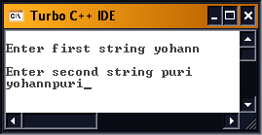

6) WAP to fetch a string and reverse it in another string

// WAP to fetch a string and reverse it in another string
#include<iostream.h>
#include<conio.h>
#include<stdio.h>
main()
{
clrscr();
char str1[20],str2[20];
cout<<endl<<"Enter first string ";
gets(str1);
for(int i=0;str1[i]!='\0';i++);
i-=1;
for(int j=0;i>=0;i--,j++)
str2[j]=str1[i];
str2[j]='\0';
cout<<"The reverse is "<<str2;
getch();
}

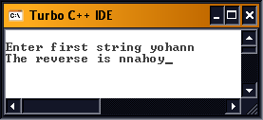

7) WAP to fetch a string and reverse it in the same string

// WAP to fetch a string and reverse it in the same string
#include<iostream.h>
#include<conio.h>
#include<stdio.h>
main()
{
clrscr();
char str1[20];
int j,k;
cout<<endl<<"Enter first string ";
gets(str1);
for(int i=0;str1[i]!='\0';i++);
i-=1;
k=i/2;

for(j=0;i>k;i--,j++)
{
str1[i]=str1[i]+str1[j];
str1[j]=str1[i]-str1[j];
str1[i]=str1[i]-str1[j];
}

cout<<str1;
getch();
}
